**Lab 3: Linux Commands - II**

**Write the following Scripts and Execute in Linux Terminal**

1. **Write a shell script to print your name.**

read -p "Enter your Name: " PERSON

echo "Hello! $PERSON"

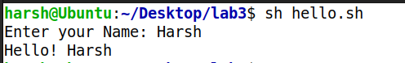

1. **Write a shell script to find whether a number is even or odd.**

read -p "Hello user, Enter a number to check whether it is odd or even: " num

if [ "$(expr $num % 2)" -eq 0 ]

then

echo "$num is even"

else

echo "$num is odd"

fi

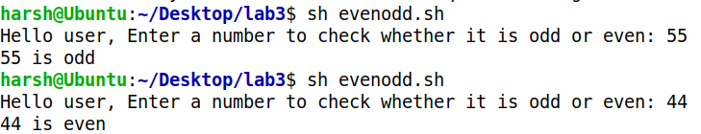

1. **Write a script to print a table of a given number.**

echo "--- Enter Number to Generate Multiplication Table ---"

read -p "Enter the number : " num

i=1

while [ $i -le 10 ]

do

echo " $num * $i = `expr $num \* $i ` "

i=`expr $i + 1`

done

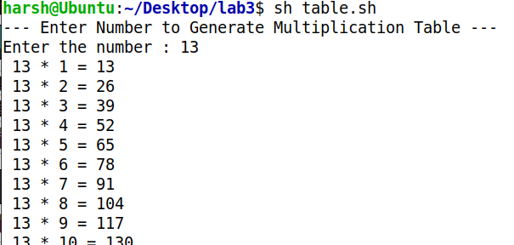

1. **Write a shell script to check whether a given no. is prime or not.**

read -p "Enter a number: " num

i=2

f=0

while [ $i -le `expr $num / 2` ]

do

if [ `expr $num % $i` -eq 0 ]

then

f=1

fi

i=`expr $i + 1`

done

if [ $f -eq 1 ]

then

echo "$num is composite (not prime)"

else

echo "$num is Prime"

fi

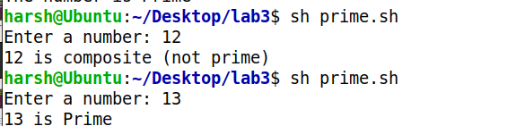

1. **Write a shell script to find the simple interest.**

read -p "Enter the principle value: " p

read -p "Enter the rate of interest: " r

read -p "Enter the time period: " t

i=` expr $p \* $t \* $r `

j=` expr $i / 100 `

echo "Simple Interest is: $j"

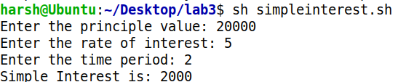

1. **Write a shell script to find sum of ‘n’ numbers.**

read -p "How many numbers do you want to sum up : " N

i=1

sum=0

while [ $i -le $N ]

do

read -p "Enter number $i : " num

sum=$((sum + num))

i=$((i + 1))

done

echo "Sum :" $sum

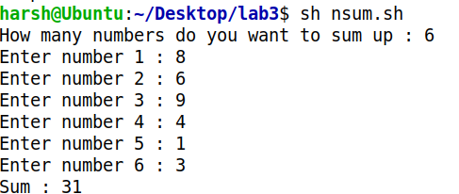

1. **Write a shell script to find the largest number of three numbers.**

read -p "Enter Num1 : " num1

read -p "Enter Num2 : " num2

read -p "Enter Num3 : " num3

if [ $num1 -gt $num2 ] && [ $num1 -gt $num3 ]

then

echo "The largest numbers among $num1, $num2, $num3 is : "$num1

elif [ $num2 -gt $num1 ] && [ $num2 -gt $num3 ]

then

echo "The largest numbers among $num1, $num2, $num3 is : "$num2

else

echo "The largest numbers among $num1, $num2, $num3 is : "$num3

fi

